William Fu

Lab 3

4. Sent over UDP

5. Destination(10.0.2.20) Port: 53

Source(10.20.65.22) Port: 60508

6. The IP address is sent to 10.10.2.22 which is the IP address of one of my local DNS servers

7. Standard Query

8.There were 3 response answers containing information on host, address, class and others

9.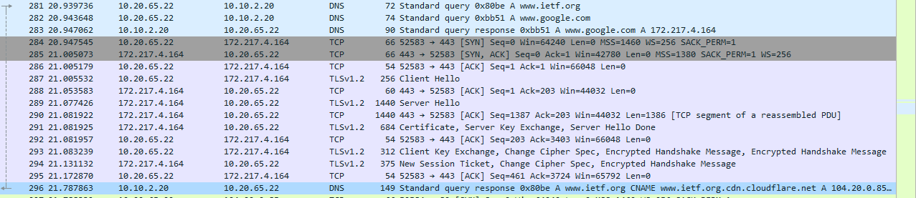

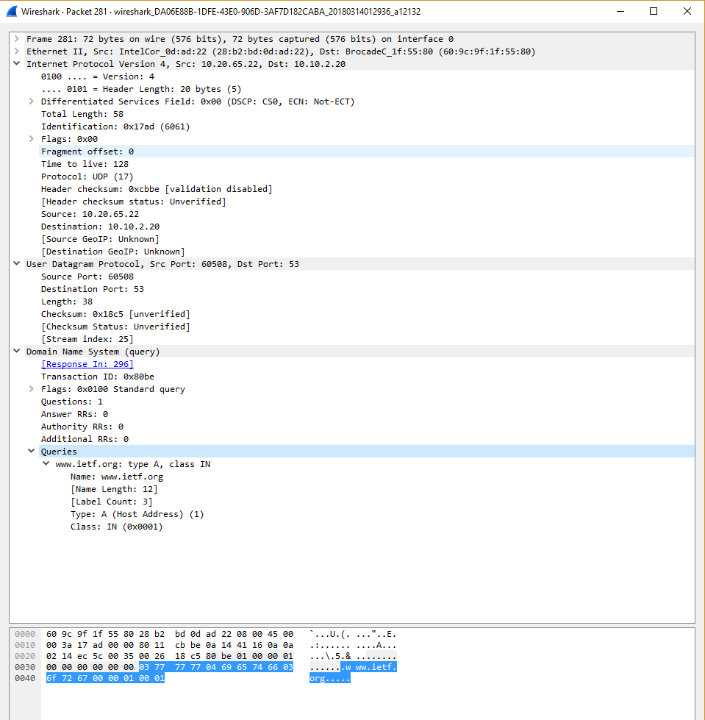

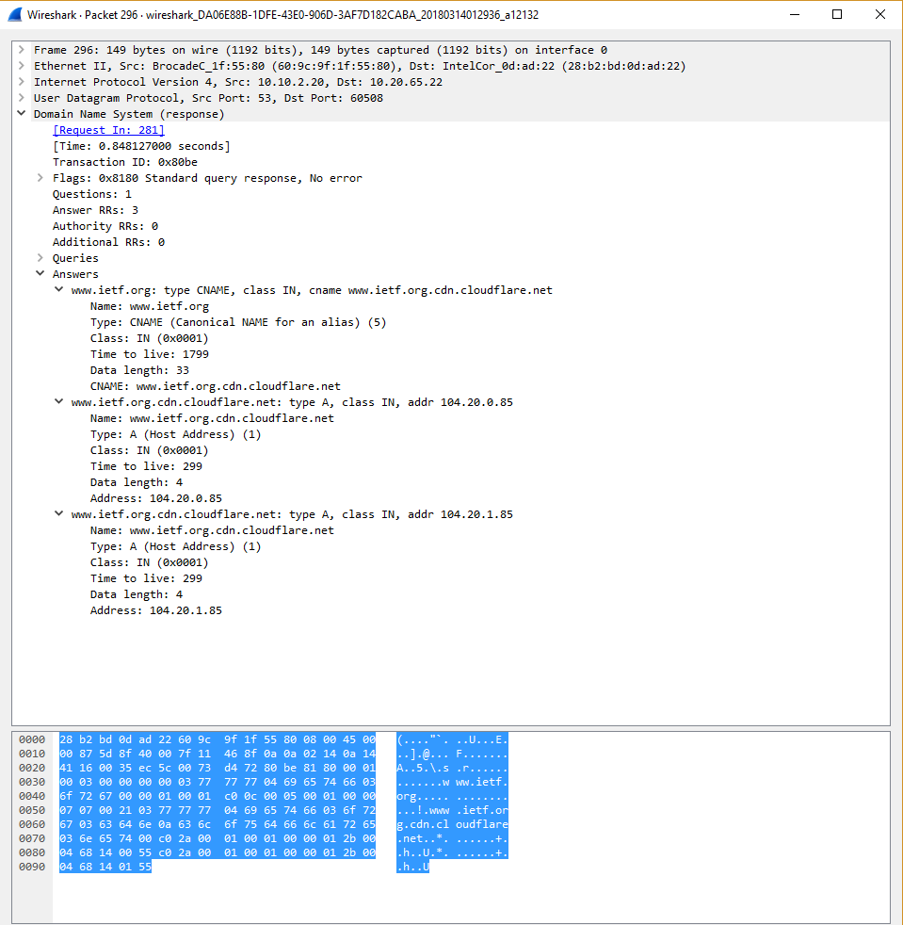

10. Destination port of DNS query: 53

Source port of DNS response: 53

11. Query sent to 10.10.2.20 and it is one of my DNS default server

12. Standard query with 0 Answer RRs

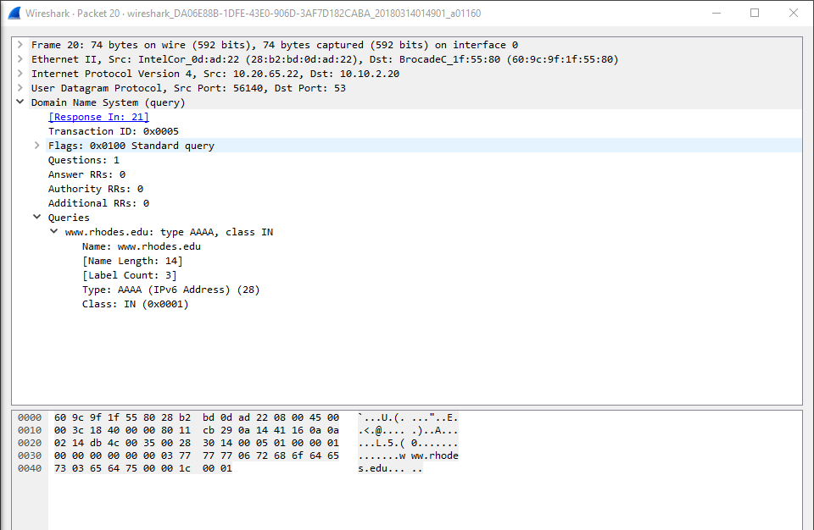

13. Response has 1 answer and contains the name of host, type of address, class and ip address

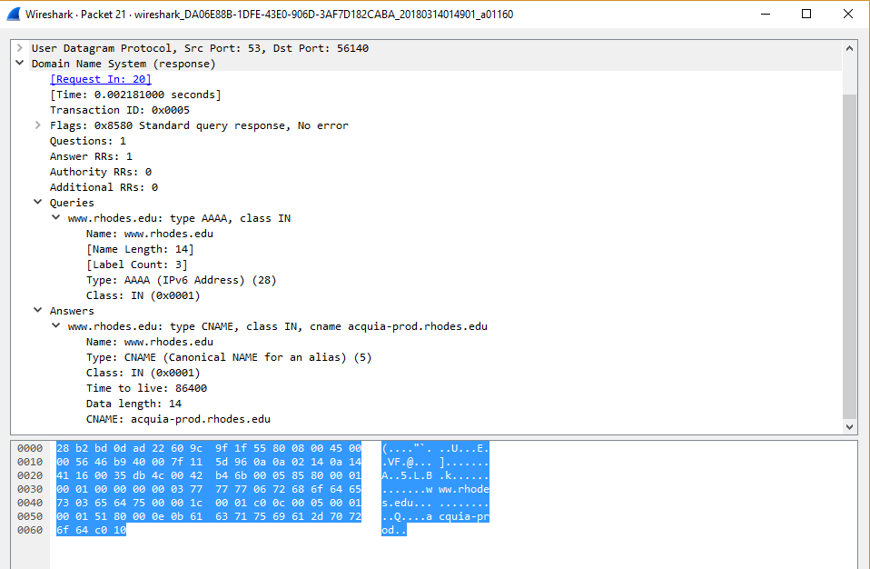

16. Sent to 10.10.2.20 and yes it is one of my default DNS servers

17. Standard query with 0 answers

18. names are : dc006.rhodes.edu

dc004.rhodes.edu

dc005.rhodes.edu

